- word formation (8 points - suggested timing 5 minutes)
- sentence transformation (14 points - suggested timing 10 minutes)
- open cloze (8 points - suggested timing 5 minutes)
There are 7 sentence transformations worth 2 points each. It is possible to get 1 point for certain answers that are partially correct.

REPRESENTATION: SPORT AND STEREOTYPING IN THE MASS MEDIA
UNIT B3.2

International sporting events, such as the Olympic Games, offer the best opportunity (for stereotypes based on
-physical characteristics
-personality types
-emotional tendencies
-historical events

Stereotyping

’Sullivan, T., Hartley, J., Saunders, D., Montgomery, M. and Fiske, J. (1994) Key Concepts in Communication and Cultural Studies, London: Routledge pp. 299–300

Stereotyping is:

the social classiﬁcation of particular groups and people as often highly simpliﬁed and generalised signs, which implicitly or explicitly represent a set of values, judgements and assumptions concerning their behaviour, characteristics or history.

In the ﬁeld of social psychology stereotyping:

has been defined as a particular extension of the fundamental cognitive processes of categorisation, whereby we impose structure and make sense of events, objects and experience. The process in itself requires the simpliﬁcation and organisation of diverse and complex ranges of phenomena into general, labelled categories. In so doing attention is focused on certain similar identifying characteristics or distinctive features, as opposed to many other differences. Stereotypes, however, not only identify general categories of people: national populations (e.g., the Irish), races (e.g., the Latin race), classes (e.g., the working class), genders (i.e. men or women), occupations (e.g., accountants) and deviant
groups (e.g., drug takers), etc., they are distinctive in the way that they carry undifferentiated judgements about their referents.
DECONSTRUCTION: stereotyping: putting a label on general categories of people, and making judgements

Whilst they may vary widely in terms of their emotional appeal and intensity, they generally represent underlying power relations, tensions or conflicts (i.e. the ‘stupid’ Irish, the ‘excitable’ Latins, the ‘cloth cap’ image, the ‘dumb blond’, the ‘boring’ accountant, the ‘evil’ junkie and so on). In short, they operate to deﬁne and identify groups of people as generally alike in certain ways – as committed to particular values, motivated by similar goals, having a common personality, make-up and so on. In this way stereotypes encourage an intuitive belief in their own underlying assumptions, and play a central role in organising common sense discourse . . .
We judge people and things through these labels.
Stereotypes influence the way we interact with people.

DECONSTRUCTION: stereotyping: putting a label on general categories of people, and making judgements
We judge people and things through these labels.
Stereotypes influence the way we interact with people.


Task B3.2.1
★

Consider the following questions.

➤ Is your nationality commonly stereotyped in the mass media both within your own country and in other countries (e.g. in newspapers and magazines, on television, in ﬁlms, and in advertising)?
➤ What particular ‘characteristics or distinctive features’ are focused on, exaggerated
and simpliﬁed?
➤ Do you think stereotypical representations of your own nationality are indicative of ‘underlying power relations, tensions or conflicts’? If so, what are these underlying power relations, tensions and conﬂicts’?

Task B3.2.2
★

Look carefully at Figure 11 on the next page.

➤ What particular ‘simple, vivid, memorable, easily grasped and widely recognized’ characteristics of the six nationalities are drawn on by the cartoonist?
➤ What particular ‘simple, vivid, memorable, easily grasped and widely recognized’
characteristics of women and men are drawn on by the cartoonist?
➤ In what ways can the stereotypical images in the cartoon be said to ﬁx national and gender characteristics ‘without change and development to eternity’?
➤ Can the national stereotypes in the cartoon be said to represent a set of values
and assumptions concerning the behaviour, characteristics or history of the people in the cartoon? (Think about both the nationalities depicted and the genders.)

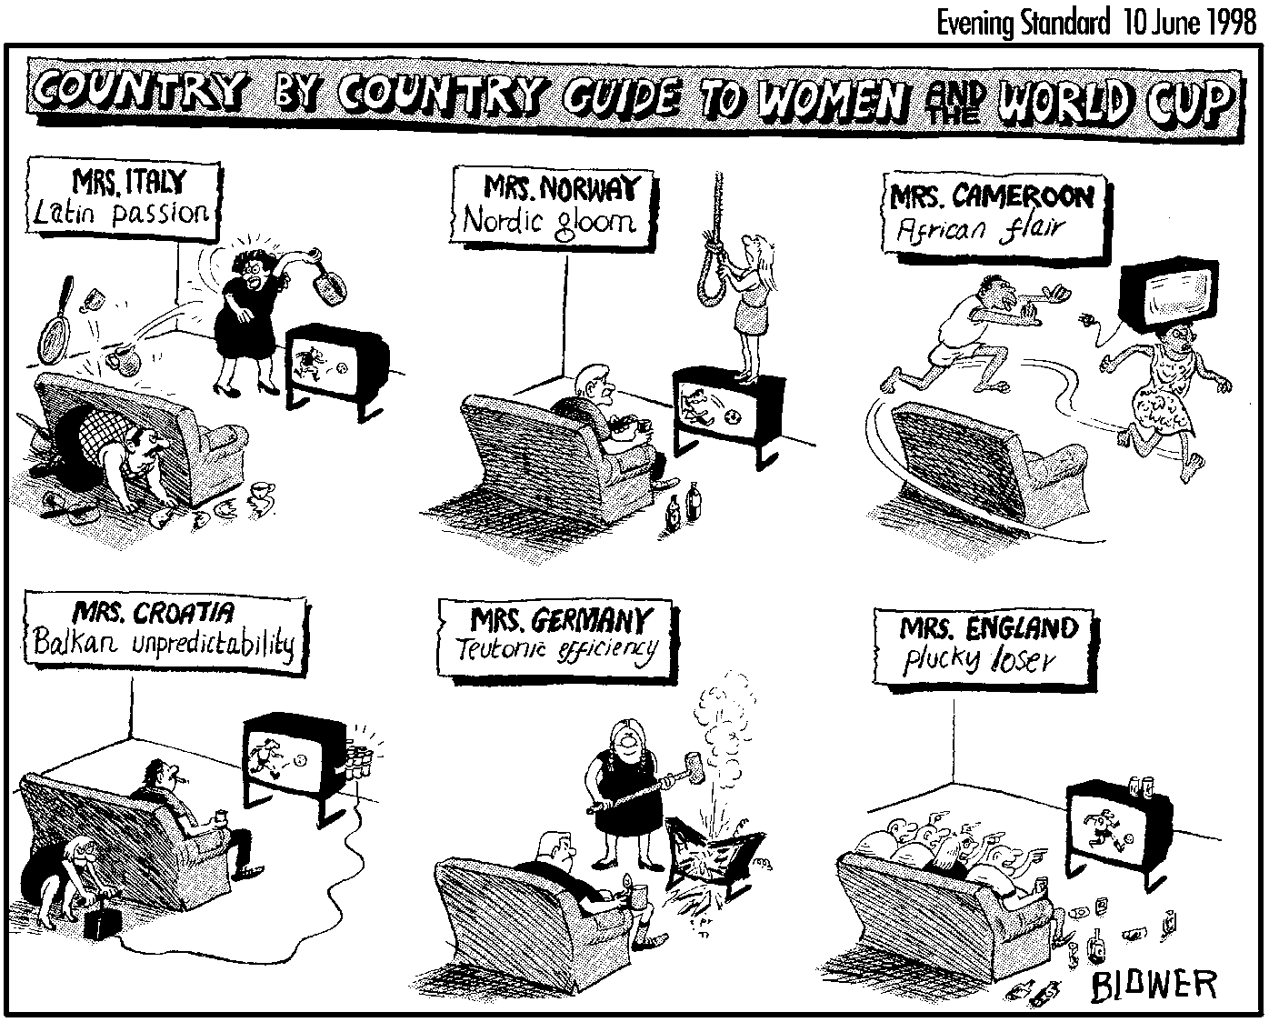

Figure 11 Cartoon from the London Evening Standard 10 May 1998

TEXT B3.2.2
H. O’Donnell

O’Donnell, H. ‘Mapping the Mythical: A geopolitics of national sporting
stereotypes’ Discourse and Society, 5:3 pp. 345–80 (1994) Sage, reproduced in O’Sullivan, T. and Jewkes, Y. (1997) The Media Studies Reader London: Edward Arnold (extracts)

The Germans
When European sports journalists refer to Germany, the dominant stereotype of national character combines the idea of strong mental control with discipline, efﬁciency, reliability and hard work: the central elements of what Spain’s best-selling daily El Pais (3 November 1993) calls ‘the German legend’. This stereotype is found throughout the European media, and is at times reﬂected in the German press itself. Thus, talking of the German football team’s national coach during Euro ’92, the German weekly magazine Stern (25 June 1992) wrote: ‘Discipline, order, punctuality – national trainer Berti Vogts leads his team in the tried and tested Teutonic tradition.’
In the terms of this stereotype, the Germans have, above all, the right mental ‘attitude’: a confidence in their ability to get the job done, and total commitment to the task in hand. In 1992, as Germany overcame Sweden 3–2 in the semi-ﬁnal of Euro ’92, the Norwegian tabloid Dagbladet (22 June 1992) wrote: ‘Their attitude is the Germans’ strongest weapon. A winning instinct and self-conﬁdence their greatest quality.’ The Norwegian quality daily Aftenposten (26 June 1992) agreed, supplying an anecdote to support its point of view. ‘German self-conﬁdence in football knows no bounds. The Germans were the only team to book their hotel rooms in Gothenburg for the European Championship ﬁnal in advance.’

During the 1990 World Cup (Italia ’90) the leading Swedish quality daily Dagens Nyheter (16 June 1990) described the German football team as a ‘machine team’, a phrase which would reappear verbatim in the Swedish tabloid Aftonbladet’s coverage of Euro ’92 (21 June 1992). The nation of mechanical efficiency accompanies German sportsmen and sportswomen across a range of sports.
H. O’Donnell

Germany= tough, self-confident, efficient, machine team. From the people to the team.
The Southern Europeans
In sports reporting on Mediterranean countries, the dominant stereotype is clearly that of the temperamental Latin, a stereotype which also extends to South America. This is one of the most deep-rooted stereotypes in northern European culture, its main elements being passion, hot temper, frivolity, sensuality, even hedonism.
This stereotype ﬁnds one of its most widespread expressions in reporting on football. The absence of Mediterranean teams during Euro ’92 meant that, in footballing terms at least, it was in the reporting of Italia ’90 that such stereotyping achieved its greatest expression, its main European bearers being the Italians. Thus the then Soviet daily Pravda (21 June 1990) assured its readers that ‘the Italian team . . . reﬂected the explosive nature of its people’. The ultimate symbol of fiery Italianness during Italia ’90 was to be Vesuvius, representing the allegedly volcanic nature of the Italian temperament. When Italy was eliminated by Argentina in the semi-ﬁnal, Bild (4 July 1990) wrote: ‘Vesuvius, Naples and all of Italy weeps’. ‘The Italians . . . went to Naples and at the edge of Vesuvius were burned by the molten lava’, added the Basque daily Deia (4 July 1990).

South Europeans- passionate, hot temper, sensual, enjoying life= Mt Vesuvius-

The South Americans
The ‘ﬁeriness’ of the Latins carries with it notions of unpredictable, even uncontrolled creativity. For all its entertainment value however, this creativity – which is often described as ‘magic’, particularly in the case of Latin Americans – is viewed unfavourably if it does not bring results. Thus, when AC Milan defeated PSV Eindhoven in the Champions’ League in 1992, PSV’s Brazilian player Romário da Souza Faria (commonly known simply as Romário) had, according to the Flemish-language Belgian daily Gazet van Antwerpen (10 December 1992), ‘conjured up a few magic tricks out of his Brazilian shufﬂe, but lacked any sense of efﬁciency’.
It is in relation to South America in particular that the ultimately damaging effect of such stereotypes comes most fully into view. Their inherent ambivalence, on the one hand, facilitates their routine reproduction, since their positive side allows their inclusion in areas of journalistic production where any suggestion of direct prejudice would be discouraged and perhaps even censored. But their negative underside – seldom expressed directly though always present in a submerged mode – is an indissociable part of the stereotype and is triggered by implication when any element of the stereotype is used. In this way apparently inoffensive characterizations contribute to the maintenance and reproduction of prejudice in a powerful but elusive form.

Stereotypes are two-faced: fieriness/creativity can become irrationality and indiscipline (positive and negative depending on what has to be highlighted

If ﬂair and creativity are the positive pole of the Southern stereotype, its negative pole brings tougher notions of indiscipline; irrationality and recklessness. In the case of the Latin Americans, ‘temperament’ usually deteriorates into supercharged emotions and complete irresponsibility. Thus the Soviet daily Izvestia (26 June 1990) reported of the Brazilians:

Sufﬁce it to say that on those days when there are matches in which the national team is taking part the number of heart attacks doubles . . . In the waiting room of a hospital in São Paulo a female patient died of a stroke – all the medical staff were enthusiastically watching the match between Scotland and Costa Rica. And while Maradona joyously waved the green-yellow strip of his defeated Brazilian opponent above his head, fourteen criminals managed to escape from the grounds of a prison also in São Paulo, taking advantage of the inconsolable grief of the guards. No one was particularly surprised: it’s football . . .

Beneath its superﬁcial humour, this report tells of social acquiescence in collective professional negligence.

Stereotypes and words can be used differently depending on the writer’s agenda.

The Africans
During Italia ’90, an unexpectedly exogenous recipient of at least parts of the Latin stereotype was to emerge: the Cameroonians. Indeed, with the early exit of Brazil from the competition, they came to be presented as ‘the Brazilians of Africa’ (El Pais, 13 June 1990), displaying, according to the German weekly Sport-Bild, ‘Brazilian artistry’ (20 June 1990). Their links with the Latin stereotype are immediately apparent, though the details of the stereotype are visibly more extreme. Thus, they are seen as sharing the ‘magic’ of the Latins – for the Hannoversche Allgemeine Zeitung (9 June 1992) they were ‘football magicians’, for Bild (16 June 1992) ‘the magicians from Africa’ – but in this case it is, in the words of the Italian daily Corriere della Sera (15 June 1992), ‘black magic’, suggesting even more unenlightened forms of religiosity than those conventionally associated with Latins.
Cameroon- black magic ‘religious magic’

Another feature of the Latin stereotype which they share is ‘temperament’, but again its expression externalizes elements of the stereotype which are often left unsaid. Thus, not only did the Hannoversche Allgemeine Zeitung (29 June 1990) describe the Cameroonians as personifying ‘African temperament’ (which it contrasted with the ‘Siberian chill’ of their Soviet trainer!) and as being themselves ‘bundles of temperament’, but L’Équipe (25 June 1990) even described their football as a ‘victory for the irrational’. . . .

Temperament-irrationality, not passion like the Europeans.

Modern sport provides an international arena in which symbolic national confrontations are played out at times before audiences of hundreds of millions. Sport is now also deeply commercialized, and, as just another form of commercial enterprise, it functions on an inter- national level as a site in which advanced countries can and must act out their preferred myths through self-and-other stereotypes, and celebrate those qualities which, in their own eyes, make them more modern, more advanced, in short superior This process routinely involves downgrading other national groups. The salience of widely disseminated schematic discursive models such as stereotypes in this process is encouraged not only by the ritualistic framework of the sporting confrontations, but also by both the demonic nature of much sports reporting and the pressure to produce dramatic reportage under which sports journalists work (Goldlust 1987:94); these circumstances combine to enhance the use-value of totemic reductionism, packing pre-formed and easily absorbed narratives into off-the-shelf formulations. And since sport continues to constitute an area of social activity in which overt emotional engagement remains publicly acceptable in ways in which this would be unthinkable in other contexts (at least in Western societies), the sports section of a newspaper is one in which a level of national sentiment and a corresponding density of highly charged national stereotypes are to be found which it is difﬁcult (at least under peacetime conditions) to imagine elsewhere.

Sports:area in which we can use us vs them stereotypes overtly with almost no problems.
Germany= tough, self-confident, efficient, machine team. From the people to the team.
South Europeans- passionate, hot temper, sensual, enjoying life= Mt Vesuvius-
Stereotypes and words can be used differently depending on the writer’s agenda.

Cameroon- black magic ‘religious magic’
Temperament-irrationality, not passion like the Europeans.
Sports: area in which we can use us vs them stereotypes overtly with almost no problems.


Task B3.2.3
★

➤ Compare the stereotypical images found in Text B3.2.2 by O’Donnell of the Germans, Italians and Cameroonians to the stereotypical images of these nationalities in Figure 11.

task B3.2.5
★

O’Donnell writes that sport is like any other commercial enterprise and, as such, ‘functions on an international level as a site in which advanced countries can and must act out their preferred myths through self-and-other stereotypes, and celebrate those qualities which, in their own eyes, make them more modern, more advanced, in short superior’.

➤ Do you agree with O’Donnell that sport is like any other ‘commercial enterprise’ in this respect?
➤ Can you think of ways in which your own nation acts out through sport and related
activities its ‘preferred myths through self-and-other stereotypes’ and celebrates certain qualities which make it seem ‘superior’?
➤ Can you identify other fields apart from sport in which nations act out their
‘preferred myths through self-and-other stereotypes’ and celebrate certain qualities which make them seem ‘superior’?

Commentary

Myths purify stereotypes
They make them innocent
a natural and eternal justiﬁcation.

