Corso di Lingua Inglese AF II 2024-2025

Giuseppina Scotto di Carlo

CORSO DI LINGUA INGLESE (ASIA E AFRICA) SECONDO ANNO
A.A. 2024-2025 partizione M_Z
Corso di Lingua Inglese AF II 2024-2025
Giuseppina Scotto di Carlo

CORSO DI LINGUA INGLESE (ASIA E AFRICA) SECONDO ANNO A.A.
2024-2025 partizione M_Z

1. AULA MOODLE:

Nome: Lingua Inglese II AF (M-Z) 2024-25 - G. Scotto di Carlo
Indirizzo: https://elearning.unior.it/course/view.php?id=8924 - hj/fvx£2w?9p

Docente: Giuseppina Scotto Di Carlo
Email: gscottodicarlo@unior.it

Anno Accademico: 2024-2025
Docente: Giuseppina SCOTTO DI CARLO
Discipline: Lingua inglese II
Settore Disciplinare: L-LIN/12 - lingua e traduzione - lingua inglese
Programma:

CFU: 8
CORSO/I DI STUDIO: AF (Lingue e Culture Orientali e Africane) 2° anno

PARTIZIONAMENTO:
TEACHING/ACTIVITY: English Language II

PREREQUISITI
Competenze e capacità linguistiche di livello intermedio/intermedio superiore
Conoscenze relative alle varietà di inglese parlate nel mondo.
Conoscenze relative alla grammatica e alla pragmatica della lingua inglese.

PROPEDEUTICITÀ
Lingua Inglese I

OBIETTIVI E RISULTATI DI APPRENDIMENTO ATTESI
Il corso fornisce un’introduzione teorica e metodologica relativa allo studio dell’inglese come lingua globale e alla comunicazione interculturale, con particolare attenzione ai contesti asiatici e africani. Obiettivo del corso è potenziare le abilità linguistiche (reading, writing, listening e speaking) attraverso testi contemporanei e autentici, incentrati sulla comunicazione in ambiti multiculturali e multietnici. Lo/la studente/essa deve possedere buona capacità di lettura e comprensione del testo in lingua inglese. La competenza linguistica iniziale del corso è di livello intermedio/intermedio-superiore e prevede il consolidamento del livello intermedio-superiore in uscita.

CONOSCENZA E CAPACITÀ DI COMPRENSIONE APPLICATE
A completamento del percorso formativo, si dovrà dimostrare di aver acquisito competenze linguistiche che consentano di produrre testi scritti e di interloquire con scioltezza sulle tematiche proposte durante il corso. A partire dalle nozioni apprese e dalle esercitazioni pratiche in aula, si dovrà dimostrare di saper interagire e comunicare in diversi ambiti e contesti dell'uso della lingua inglese. Inoltre, si dovrà saper utilizzare gli strumenti metodologici forniti per l'analisi e l’uso di competenze interculturali e sociolinguistiche applicate a testi autentici.

ULTERIORI RISULTATI DI APPRENDIMENTO ATTESI

Autonomia di giudizio:
Capacità di analizzare criticamente testi complessi in lingua inglese, nonché di discutere in modo personale questioni emergenti dai testi proposti in classe.

Abilità comunicative:
Abilità di comprensione e produzione del testo pari al livello B2+/C1 (CEFR).

Capacità di apprendimento:
Dimostrare un'autonomia di apprendimento e di applicazione delle strutture linguistiche oggetto del

corso; essere in grado di utilizzare gli strumenti di analisi nell'uso corrente della lingua inglese nei campi di studio propri del corso di Laurea Triennale in Lingue e Culture Orientali e Africane.

METODOLOGIA DI INSEGNAMENTO
Didattica frontale in inglese, uso di case studies, esercitazioni di ascolto e dibattiti in classe, affiancate da attività di analisi e comprensione di testi. Le attività svolte in classe saranno rese disponibili online su piattaforma MOUVE (CLAOR), accessibile anche a coloro che non frequentano le lezioni.
Le lezioni frontali del docente verranno svolte nel secondo semestre. Durante tutto l’anno accademico sono previste esercitazioni pratiche con i collaboratori linguistici che costituiscono parte integrante del programma.

PROGRAMMA

Titolo del Corso: L'inglese per la comunicazione interculturale

- La comunicazione interculturale: caratteristiche, procedure e strategie
- L’identità in un contesto multilingue e multiculturale (focus Asia/Africa)
- Comunicazione, potere e discorso
- Dominanza linguistica inglese, dominanza socioculturale e mantenimento linguistico
- Culturespeak e identità in una Londra multi-etnica
- Comportamenti linguistici e ideologie del linguaggio
- Identità e Apprendimento Linguistico
- L’immagine di sé e dell’Altro attraverso i media
- Razzismo, lingua e società: la rappresentazione dell’Altro da sé

CONTENTS

Course Title: English for Intercultural Communication

- Intercultural communication: characteristics, procedures and strategies
- Identity in a multilingual and multicultural context (Asia/Africa)
- Communication, power and discourse
- English linguistic dominance, socio-cultural dominance and linguistic maintenance
- Culture speak and identity in multi-ethnic London
- Linguistic behaviors and language ideologies
- Identity and Language Learning
- Otherizations and the media

- Racism, language and society: the representation of the Other
TESTI DI RIFERIMENTO/BIBLIOGRAFIA

Holliday, A., M. Hyde, and J. Kullman. 2017. Intercultural Communication: An Advanced Resource Book for Students (3rd edition). London/New York: Routledge.
-Eventuali ulteriori materiali saranno caricati sulla piattaforma E-Learning (v. pagina personale docente per la password).

MODALITÀ DI ACCERTAMENTO DEL PROFITTO
L’esame si articola in: accertamento linguistico (scritto, svolto tramite la piattaforma MOODLE) e prova orale.
La prova scritta sarà costituita da domande a risposta multipla e a risposta libera, riguardanti aspetti della lingua inglese trattati dai Collaboratori ed Esperti Linguistici.
La prova orale riguarderà gli argomenti trattati durante il corso metodologico svolto dalla docente titolare del corso.
Lingua in cui si svolge l’esame: Inglese

Criteri di valutazione:

La valutazione finale può variare da 18/30 a 30/30 in ragione del livello di accuratezza e completezza del colloquio orale e del corretto impiego di metodologie e teorie nonché della padronanza della lingua inglese.
Il livello di valutazione minimo (18/30) all'interno del livello richiesto è attribuito quando lo/la studente/essa dimostra una incerta o parziale padronanza nell'applicazione delle conoscenze e dei metodi studiati, e ha una conoscenza frammentaria o limitata ai soli fondamenti basilari dei vari argomenti affrontati. Lo/la studente/essa dimostra, inoltre, una padronanza minima della lingua inglese nell'argomentare ed esporre le proprie tesi, parzialmente in linea con un livello intermedio-superiore di padronanza della lingua inglese.
Il livello di valutazione massimo (30/30) all'interno del livello richiesto è attribuito quando lo/la studente/essa dimostra una padronanza completa e approfondita nell'applicazione delle conoscenze teoriche e dei metodi di analisi studiati, ed è in grado di risolvere i problemi affrontati in modo critico e accurato. Lo/la studente/essa dimostra inoltre una padronanza elevata della lingua inglese nell'argomentare ed esporre le proprie tesi senza incertezze, in linea con un livello intermedio-superiore di padronanza della lingua inglese.
La lode viene attribuita quando lo/la studente/essa dimostra una assoluta padronanza dei contenuti teorici e metodologici, la capacità di correlare i diversi argomenti trattati in maniera trasversale, ed è in grado di presentare gli argomenti con notevoli capacità espressive. Viene altresì valutata l'autonomia di giudizio dimostrata nella selezione di testi alternativi a quelli proposti dal docente per approfondire le tematiche affrontate nell'analisi.

SECTION A
Introduction: Defining concepts

Theme 1Identity

Construction of identities

Identity qualities, beliefs, personality, looks and/or expressions that make a person or group.

Individual or collective identity.
psychological identity relates to self- image.

Peter Weinreich :
"A person's identity is defined as the totality of one's self-construal, in which how one construes oneself in the present expresses the continuity between how one construes oneself as one was in the past and how one construes oneself as one aspires to be in the future";
ethnic identity: "One's ethnic identity is defined as that part of the totality of one's self-construal made up of those dimensions that express the continuity between one's construal of past ancestry and one's future aspirations in relation to ethnicity".
social identity, or the collection of group memberships that define the individual. Sociology places some explanatory weight on the concept of role-behavior.

Identity negotiation may arise from the learning of social roles through personal experience. Identity negotiation is a process in which a person negotiates with society at large regarding the meaning of their identity.
Gender identity how one views oneself both as a person and in relation to other people, ideas and nature.[
Other aspects of identity- racial, religious, ethnic, occupational
Linguistic identity refers to a person's identification as a speaker of one or more languages. The linguistic identity is part and often an important part of our identity.

PEOPLE LIKE ME
‘This is whom I want to be represented by’

Experience

Example A 1.1.1 Being represented
Parisa had been coming to international conventions on food processing for several years. She had made several good friends; but there was a gnawing problem which always came back unresolved. She was the only person at the convention who came from her country; and no matter how friendly and sincere, she knew that her colleagues saw her in a particular way which just wasn't her at all. lt was from their passing comments, their casual, unguarded turns of phrase, in which they seemed to show surprise when she was creative, assertive or articulate, as though she ought to be somehow unable to be good at all the things she did. One of her colleagues did not actually say 'well done! but certainly implied it in her tone of voice.
She also felt isolated as the only person from her particular background at these conventions. There was nobody else to represent who she was. lt also hurt her when someone said that because they thought of her as being 'like them' really, that she was 'not a real' representative of her 'culture'. This seemed like a no-win situation. lf her behaviour was 'recognised', she was not real; and if she

was considered 'real', she wasn't supposed to behave like that. She didn't mind them thinking that she was like them, but certainly not at the expense of not being a person on her own terms.


Parisa's colleague said that she had no idea such women existed in her country, and that she
Then something happened which both confirmed her fears and gave her support. She invited three
of her colleagues to see a film that was directed by someone from her country which was showing at the local university. They came willingly - very interested. When she asked one of them what she found so fascinating, she replied that she was particularly impressed by the female characters who portrayed such strong women. lndeed, a woman played a major executive role in a film crew.
She hired and fired people and drove around in a jeep.
because the women inthe film, while being very independent, were at the same time certainly 'real' in that they wore traditional clothes, and the woman who drove the jeep wore the black headscarf and long coat that she imagined fitted the 'stereotype'.

Shortly after this, another person from her country arrived at the convention. Parisa was very pleased that he was educated, worldly, urbane, well-dressed and also extremely articulate. This was no moreor lessthan she would expect of her countrymen; but she was pleased because here wasfurther evidence for her other colleagues of the sort of people she belonged to. Moreover, itwas veryclear that-he had tremendous respect for her as an equal, an academic and a professional. Parisa wondered though if they considered him a 'real' representative of their 'culture'. After all, he wore a smart suit and didn't have a beard.

Afterwards though, she thought more about this. Why shouldn't he have a beard? She was worried that not having a beard meant that after all he was leaving his culture, and that the people at the conference would think that he was 'modern' because he didn't have a beard and was therefore 'like them'? No, the point she wanted to make was quite different to that. She, and all her countrypeople could be modem or not, whether they fitted the stereotype of 'traditional' appearance or not. Him not having a beard simply illustrated the possibility of this diversity to her colleagues at the conference

Deconstruction
Parisa’s friends lack real knowledge of her cultural background.
They are vulnerable to stereotypes.
 | 1. | Multi-facetedness: stereotypes simplify too much:
 | Parisa wants to be identified as Iranian, but also likes the man who does not conform to the typical

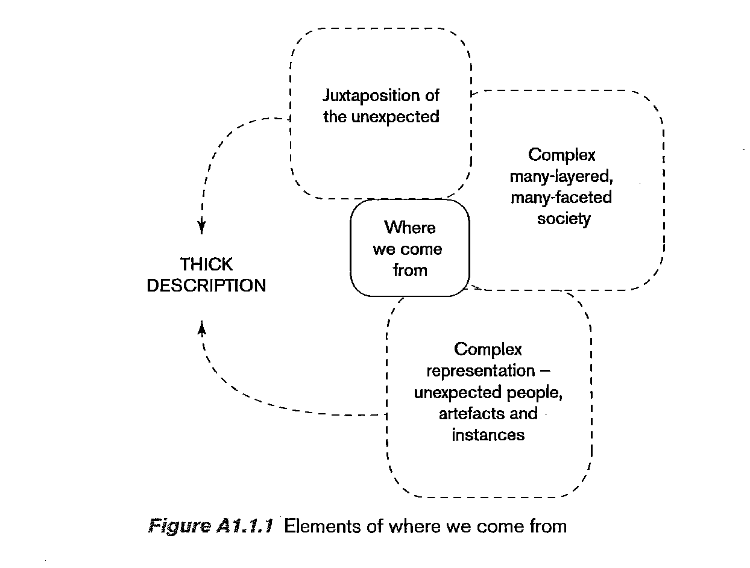
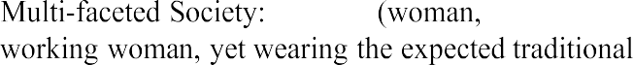
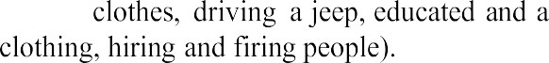
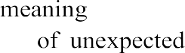
Iranian man.

EXPECTED Means stereotype VS UNEXPECTED is complex reality a society is more than any outsider can imagine.

encounters with people, artefacts and instances (Parisa's new colleague, the film, how the new colleague treats Parisa)

She wantsher colleagues to understand that her society is complex.

The way people talk

'passing comments' annoy her: 'well done!
People are unaware, they do not see it as derogatory.

Communication
Parisa's colleagues use established stereotypes. What should we do instead?
1. Respond to people according to how you find them rather than according to what you have heard about them.
- Avoid easy answers about how people are. Bracket -put aside simplistic notions about what is 'real' or 'unreal' in your perception of 'another culture'.
- Appreciate that every society is as complex and culturally varied as your own.
- Learn to build up thick descriptions of what happens between you and others
Task A 1.1.1 Thinking about Parisa
> Explain how you can better understand one or more people in the situation with the help of Figure Al.1.1 and the disciplines listed above.
ARTEFACTS OF CULTURE
Telling cultural stories, closing ranks

Experience
This unit continues to unravel the complexities of cultural identity by looking at what might lie behind what people say about their culture.

Example A1.2.1 Chinese teachers
Janet is American and got to know Zhang and Ming, who are Chinese, when they were doing their master’s course together. She found that Zhang talked a lot both in classand at other times about Confucianism and how it was the basis of Chinese culture. They soon got into an ongoing discussion about what teachers and students could be expected to do in his university English classes. He said that because of Confucianism, just as it was impolite for children to question their parents, it was impolite for studentsto question their teachers. This meant that all sorts of things which happened in class-rooms in the West, like discovery learning and classroom discussions, were culturallyinappropriate in China.

As the master’s course progressed, Janet noticed that Zhang was getting increasingly unhappy. She asked Ming what Zhang’s problem was. He explained that some people found it more difficult than others to cope with being in a foreign environment. She had noticed that Zhang was very silent when there was a class discussion, and she asked Ming if this was to do with Confucianism. Ming said that this was certainly a factor; but when Janet told him what
Zhang had told her about students having to obey their teachers in China, Ming said that this was not strictly true – that he knew lots of teachers who were prepared to be engaged in discussion by their students, that students were certainly not always prepared to submit to teachers who would not listen to them, and that in modern China many parents no longer held the sort of authoritythat Zhang was talking about.
Janet told him that this shocked her because it wasnot just from Zhang that she had heard about this. There were so many books she had read about Chinese culture which reported how it was bound by Confucianism. There were also two other people on the course who said that all the Chinese people theyhad met said the same thing.
Ming said that there were different ways of looking at this. On the one hand, it could not be denied that Confucianism had been a very powerfulinfluence on Chinese society for thousands of years. On the other hand, not everyone had to be bound by this influence; and different people could be influenced in differentways.

Janet then read an article which said that people in the developing world had tended to exaggerate their own cultural identity in order to counter the powerful influence of the West. She read Kubota (2002). When she put this idea to Ming he said that therewas no need to read too much into Zhang’s statements about Confucianism. He thought it was really far more simple than that. He had seen so many American people in China who had seemed far more ‘American’ than anyone he had seen here. Surely was it notthe case that all people drew more heavily on certain cultural resources when they felt culturally threatened by strange behaviour. So doesthat mean that Confucianism is a‘cultural resource’ she wondered.

Deconstruction
Zhang presents an essentialist view – that ‘Chinese culture’ is characterized by Confucianism Ming is more non-essentialist –he does not deny the complexity of one’s identity and society
the reasons for Zhang’s essentialist point of view? When people are in a difficult, strange environment, they can exaggerate specific aspects of their cultural identity. What people say about their cultural identity should be read as the image they wish to project

Closing ranks
This reminds one also of the observed behaviour of Japanese students in British classrooms. Their silence and apparent ‘passivity’ may be more a reaction to the, to them, strange

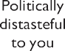
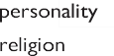

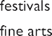

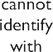
classroom rules which confront them than an effect of cultural behaviour in Japan.

Cultural resources

Confucianism for the Chinese teachers thus becomes a convenient cultural resourcearound which to protect their threatened identity.

Cultural resources, e.g.:
ceremonies

Setting 2

moral code

culture you
who you are

Figure 2 Making use of culture
cultural resources: aspects of culture that exist in our society. The surrounding bubbles are examples of cultural settings which are ‘foreign’
- You strengthen your identity by drawing on ceremonies, festivals and family values in your society or social group and present these as the basis of your culture.

Artefacts of culture

what can be said about Zhang is that his discourse about Confucianism is part and parcel of his cultural identity. The way he talks about Confucianism is an artefact of what hebelieves about Confucianism; and this in itself may indeed be cultural.

Table 2 What people say
Essentialist description based on stereotypes
In Chinese culture people’s behaviour is determined by Confucianism Children do not interact in the classroom

While respecting whatever people say about their own culture, take what they say as evidence of what they wish to project rather than as information about wherethey come from.
Take what people say about their own culture as a personal observation which should not be generalized to other people who come from the same background.


Task A1.2.1 Thinking about Zhang and Ming

➤ ➤ Explain how you can better understand one or more people in the situation with the help of the explanations in the Deconstruction section, Table 2 and the disciplines listed.
➤
of the participants and why.

