AFII coursebook and Exam Preparation

The language for the exam will be based on:
English File Upper-Intermediate digital 3rd edition (OUP)
(all the book, but emphasis on UNITS 4-10)

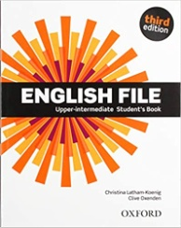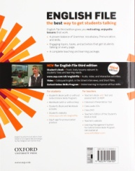

Link to practice exercises and other resources:
https://elt.oup.com/student/englishfile/upperint3/?cc=it&selLanguage=it

Link to mock test:
https://elearning.unior.it/mod/quiz/view.php?id=64532

For any queries contact sbhaslam@unior.it

Most important language points:
Conditionals (0,1st,2nd,3rd & mixed)
Structures after “wish”
Verb patterns (gerund and infinitive)
used to & be/get used to
Past modals
Verbs of the senses
Passive forms
Reporting verbs
Clauses of contrast and purpose
Uncountable nouns and singular/plural
Quantifiers (all, every ..)
Articles
Future Tenses

Exam Day
Remember that you need to do the exam using your unior email and you must be registered on the Unior elearning Moodle.
You need to use a pc, with a stable internet connection and you must have your camera and microphone on throughout the exam.
You must respect the rules set by the university regarding exam procedure

