What is an inversion with a negative adverbial?
In formal English, we can place a negative or restrictive adverb at the beginning of a sentence to make the sentence more emphatic or dramatic. When we do this, the adverb is then followed by an inversion: auxiliary verb + subject (+ verb). See the example below:
- I could find my keys nowhere. ⇒ Nowhere could I find my keys.
When there is no auxiliary verb, we use do/does (present) or did (past) as auxiliary.
- I understand the true meaning only now. ⇒ Only now do I understand the true meaning.
- I didn’t say anything until she arrived. ⇒ Not until she arrived did I say anything.

Common adverbs used with this structure
In the table below you can see some of the most common negative or restrictive adverbials that are sometimes used at the beginning of the sentence for emphasis.
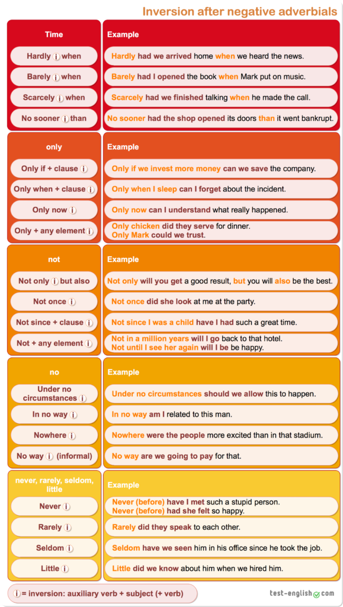

Hardly, barely, scarcely, no sooner
We normally use hardly … when, barely … when, scarcely … when, and no sooner … than in narratives with past perfect in the inversion.
We use no sooner … than (NOT , or )

Adverbial + clause + inversion
Note that after some adverbials, such as only if and only when we use a subordinate clause (subject + verb), and that the inversion is never in the subordinate clause but in the main verb of the sentence. Check the sentence below:
- Only when I sleep can I forget about the accident. (NOT: …)
The same happens with other adverbials, such as not since and not until; we use a subordinate clause (subject + verb), and the inversion is never in the subordinate clause but in the sentence’s main verb. Check the sentence below:
- Not since I was a child have I had such a great time. (NOT: …)
If you are in doubt, it’s always useful to look at the sentence without the negative adverbial at the beginning.
- I can forget about the accident only when I sleep.
- I haven’t had such a great time since I was a child.
The main subject and verb are at the beginning of the sentence, and this is the element that must be in the inversion.

Not
We must always use not followed by another element before the inversion.
- Not often can we see such great expressions of art. (NOT .)

Adverbs of frequency
We can also use inversion after the negative or restrictive adverbs of frequency, such as seldom, rarely, or never.
We often use never to talk about experiences. In that case, we normally use present perfect or past perfect.

